library(dummies)

## dummies-1.5.6 provided by Decision Patterns

library(GGally)

## Loading required package: ggplot2

## Registered S3 method overwritten by 'GGally':  
## method from   
## +.gg ggplot2

library(gplots)

##   
## Attaching package: 'gplots'

## The following object is masked from 'package:stats':  
##   
## lowess

toyota <- read.csv(file = "C:/Users/abhis/Documents/R Studio/datasets/ToyotaCorolla.csv", header = TRUE)

#a  
#The categorical variables in this dataset are: Model, FUel_type, Color, Met_Color, Mfr_Month, Mfr_Year, Automatic, Mfr_Guarantee, BOVAG_Guarantee, ABS, Airbag_1 , Airbag_2 , Airco , Automatic_airco , Boardcomputer , CD_Player , Central_Lock , Powered_Windows, Power_Steering, Radio, Mistlamps, Sport_Model, Backseat_Divider, Metallic_Rim, Radio_cassette , Parking assistance system, Tow_Bar  
  
#b  
# A Dummy variable or Indicator Variable is an artificial variable created to represent an attribute with two or more distinct categories/levels.A variable with N categories will be converted to N or N-1 dummy variables. We create dummy variables for categorical data as yes or no which are converted to 0 and 1.  
  
#c  
# N or N-1 variables are required to capture the information in a categorical variable  
  
#d  
  
toyota$Mfg_Year <- factor(toyota$Mfg_Year)  
  
toyotadummy <- dummy.data.frame(toyota[,-c(1,2,5,6,11,15)])

## Warning in model.matrix.default(~x - 1, model.frame(~x - 1), contrasts = FALSE):  
## non-list contrasts argument ignored

#One of the example for this is: The Fuel_Type variable which has three category, Petrol, Diesel and CNG. This results in three different dummy variables Fuel_Type_Petrol, Fuel_Type_Diesel and Fuel_Type_CNG  
  
#e  
  
#Correlation Matrix  
Cor_Matrix <- round(cor(toyotadummy),2)  
  
  
  
  
#After analysing Variables which are not important seeing the Correlation matrix excluded-  
#Radio_Cassette,Tow_Bar, Parking_Assistant,Mettalic_Rim, Backseat_Divider  
#Sports_Model,Mistlamps,BOVAG_Guarantee, Mfr_Guarantee, Automatic, Met_Color  
#Radio and radio_cassette have high correlation 0.99 correlation so only radio is considered  
Toyota_a <- toyotadummy[,-c(8,9,15,16,29,30,31,32,33,34,35)]  
  
  
#Heatmap to analyse all data  
heatmap.2(cor(Toyota_a), Rowv = FALSE, Colv = FALSE, dendrogram = "none",  
 cellnote = round(cor(Toyota_a),2),  
 notecol = "black", key = FALSE, trace = 'none', margins = c(10,10))

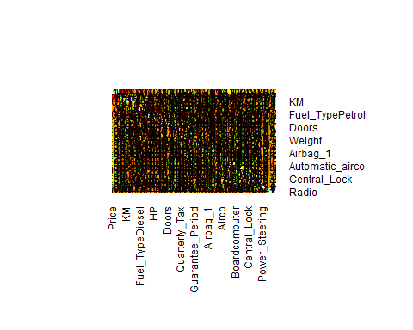

# All continuous variables  
Toyota_Co.df <- toyotadummy[,c(1,2,3,7,10,11,12,13,14,17)]  
  
  
#Heat Map for only continuous variables  
  
  
heatmap.2(cor(Toyota_Co.df), Rowv = FALSE, Colv = FALSE, dendrogram = "none",  
 cellnote = round(cor(Toyota_Co.df),2),  
 notecol = "black", key = FALSE, trace = 'none', margins = c(10,10))

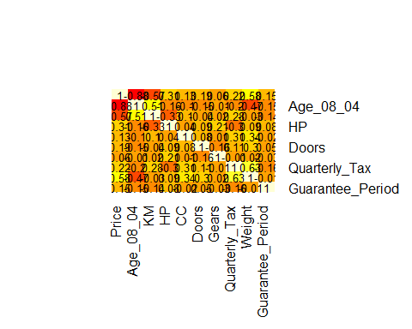

#After analysing data other highly Correalted variables which are dropped:-  
#CC, Doors, Gears, Guarantee period  
  
Toyota_Drop.df <- Toyota_Co.df[,-c(5,6,7,10)]  
  
  
  
#Heat Map of only relevant continuous variables  
#Continous Variables relevant- Price,Age,KM,Quaterly_Tax,Weight,HP  
  
  
heatmap.2(cor(Toyota_Drop.df), Rowv = FALSE, Colv = FALSE, dendrogram = "none",  
 cellnote = round(cor(Toyota_Drop.df),2),  
 notecol = "black", key = FALSE, trace = 'none', margins = c(10,10))

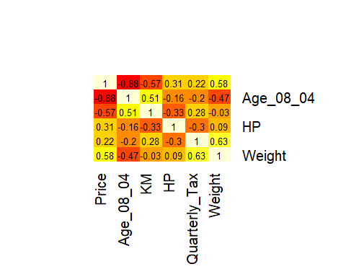

y<-Toyota_Drop.df  
  
#Only Continuous variables for Correlation matrix:-  
Cor_Matrix <- round(cor(y),2)  
  
  
#Matrix scatter plot Continous variables   
ggpairs(Toyota_Drop.df)

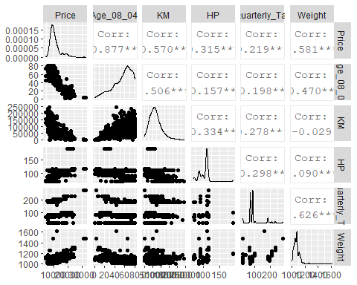

#After the analysis of several variables. The corelation between multiple variables in considered:  
#Age_08_04 is negatively correlated with price (-0.88): This means when the age of the car is more the price of the car goes down.KM is negatively correlated with price(-0.57): When the km increases similar to age the price of the car decreases. Weight is positively correlated with price(0.58): Weight of the Car is positively correlated with the Price (higher price higher weight). KM is positively correlated with Age_08_04( 0.51): Other than price, KM and Age of Car is positively stating a increasing relationship for both the factors when one increases. Weight is positively correlated with quarterly tax(0.63) : Quarterly Road Tax collected is positively related to Weight stating higher Car weight higher the Quarterly road tax.